RETROFITTING AS A PATHWAY TO REDUCE ENERGY CONSUMPTION IN NIGERIA'S HOSPITALITY INDUSTRY
Umar Abdulazeez Saidu
Department of Architectural Technology,
Federal Polytechnic Ukana, Akwa Ibom State.

Hannah Yetunde Obamoh
Department of Architectural Technology,
Federal Polytechnic Ukana, Akwa Ibom State.

Etim Kereidem Boniface
Department of Architectural Technology,
Federal Polytechnic Ukana, Akwa Ibom State.
Corresponding Author: saidu.umar@fedpolyukana.edu.ng
ABSTRACT
Nigeria's hospitality industry faces mounting pressure from high energy demand, unreliable grid supply, rising electricity tariffs and heavy dependence on diesel generators. Hotels require uninterrupted power for cooling, lighting, water heating, kitchens, refrigeration and laundry, yet most existing facilities were neither designed nor operated with strong energy-efficiency considerations, resulting in high operating costs and weak competitiveness.
The study adopted a qualitative desk review design supported by comparative synthesis of recent peer reviewed literature, global energy reports, Nigerian electricity data and documented retrofit performance ranges. Reviewed materials were analysed using qualitative content analysis, grouped into themes covering energy-use profile, retrofit technologies, saving potential, barriers, financing and policy implications.
Staged retrofit packages combining LED lighting, occupancy controls, HVAC optimisation, building-envelope improvement, smart energy management and solar photovoltaic integration can reduce total hotel energy demand by about 20-45 percent, depending on building condition, occupancy level and implementation quality. Key barriers include high upfront cost, limited technical expertise, weak enforcement of energy standards and inadequate green finance.
Retrofitting is a practical and financeable pathway to reducing energy consumption in Nigerian hotels. The study recommends mandatory energy audits for medium and large hotels, phased retrofit planning, energy performance contracting, capacity development for facility managers and targeted policy incentives for energy-efficient hospitality buildings.
Keywords: Retrofitting, Energy efficiency, Hospitality industry, HVAC systems, Renewable energy and Nigeria.

INTRODUCTION
Energy is central to hospitality service delivery because hotels operate continuously and must provide thermal comfort, lighting, water heating, catering, laundry, refrigeration, security and entertainment services. The global buildings and construction sector remains a major energy and emissions concern, with recent status reports emphasising the need to accelerate efficiency, electrification and low-carbon building operation (UNEP & GlobalABC, 2024; IEA, 2024). For hotels, the issue is more complex because guest-comfort expectations often encourage long operating hours for air-conditioning, water heating and lighting systems.
In Nigeria, the energy challenge is intensified by unstable grid electricity, high cooling demand and dependence on self-generation. National electricity statistics show persistent fluctuations in supply, while hotels must still maintain 24-hour service delivery (NBS, 2024; NERC, 2024). Consequently, many hotels rely on diesel generators as a backup or primary power source, which raises operating costs, increases carbon emissions and reduces the competitiveness of hospitality businesses.
Retrofitting offers a realistic response because it focuses on improving existing hotel buildings rather than replacing them. It involves upgrading inefficient equipment, improving building fabric, introducing smart controls and integrating renewable energy systems. In a developing economy where many buildings are already in use and capital for new construction is limited, retrofit is often more practical than demolition and reconstruction.
RESEARCH PROBLEM AND RESEARCH GAP
Existing studies confirm that buildings and hotels can reduce energy demand through improved lighting, HVAC control, insulation, energy monitoring and renewable energy integration (Ma et al., 2012; González et al., 2018; IEA, 2024). Nigerian studies have also shown that hotel energy consumption is affected by generator dependence, inefficient equipment and weak energy management practices (Oluseyi et al., 2016; Zhiri & Bawa, 2024). However, three gaps remain. First, many Nigerian hospitality energy studies provide useful evidence on energy use but few present a consolidated retrofit pathway that hotel managers can follow from audit to monitoring. Second, much of the available retrofit evidence originates from developed economies or non hospitality buildings, making direct application to Nigerian hotels uncertain without contextual interpretation. Third, although recent global policy discussions emphasise building decarbonisation and energy efficiency, limited practical synthesis links these global directions to Nigeria's hotel sector, particularly regarding phased implementation, financing and measurable retrofit priorities.
This paper responds to these gaps by synthesising current evidence into a structured framework that identifies retrofit options, indicative energy saving ranges, adoption barriers and implementation steps for hotels in Nigeria.
AIM AND OBJECTIVES
The aim of this paper is to examine retrofitting as a pathway for reducing energy consumption in Nigeria's hospitality industry.
The specific objectives are:
- To identify major energy consuming systems in hotel buildings.
- To examine retrofit strategies suitable for Nigerian hotels.
- To assess the energy saving and operational benefits of retrofitting.
- To identify barriers to retrofit adoption.
- And to propose a practical implementation pathway for hotel operators, built environment professionals and policymakers.
LITERATURE REVIEW
Building retrofitting refers to the improvement of existing buildings through technical, operational and fabric-based interventions that reduce energy demand while maintaining or improving performance. Retrofit actions may include LED lighting, improved HVAC equipment, smart thermostats, occupancy sensors, better glazing, roof insulation, solar photovoltaic systems, solar water heaters and building management systems. Retrofitting is valuable because it addresses the large stock of buildings already in operation, which will continue to dominate the built environment for many years.
Hotel buildings are energy intensive because they combine residential, commercial, catering and leisure functions. Earlier building-energy literature identified HVAC, lighting and equipment as major end-uses in buildings (Pérez-Lombard et al., 2008). More recent hotel studies continue to show that HVAC and cooling systems dominate energy use, especially in hot climates and hotels with high occupancy or poor operational control (Agharid et al., 2024; Zhiri & Bawa, 2024). Retrofit planning in Nigerian hotels must therefore prioritise cooling efficiency, lighting efficiency and operational control.
Current global reports support the relevance of this study. The IEA's Energy Efficiency 2024 report describes energy efficiency as a key strategy for managing demand, reducing costs and improving energy security (IEA, 2024). The UNEP and GlobalABC buildings report stresses that building sector progress remains insufficient and that stronger policy, finance and technology adoption are needed to align buildings with climate and sustainability goals (UNEP & GlobalABC, 2024). These findings are directly relevant to Nigeria's hospitality industry because energy cost and reliability are already major operational risks.
METHODOLOGY
The study adopted a qualitative desk review design. Secondary data were drawn from peer reviewed journal articles, conference papers, government electricity reports, international energy reports and sustainability publications relating to hotel energy use, building retrofitting and energy efficiency. Source selection was purposive and based on relevance to hotel buildings, energy consumption, retrofitting, tropical climates, developing economies and Nigeria's electricity context.
The reviewed materials were analysed using qualitative content analysis and comparative synthesis, grouped into key themes: energy-use profile of hotels, retrofit technologies, saving potential, implementation barriers, financing options and policy implications. The numerical values presented in the tables and figures are therefore indicative ranges synthesised from the literature, not direct measurement from a single hotel. This approach is appropriate for the objective of the paper, which is to develop a practical retrofit pathway for scholarly discussion and further empirical research.
RESULTS AND DISCUSSION
Energy Consumption Pattern in Hotel Buildings
The reviewed evidence shows that cooling related electricity demand is usually the largest energy burden in hotels located in warm climates. Lighting, water heating, kitchen and laundry operations, refrigeration and other plug loads also contribute significantly. Figure 1 presents an indicative hotel energy use profile, actual values may vary according to hotel size, room occupancy, equipment age, climate, staff behaviour and maintenance culture.
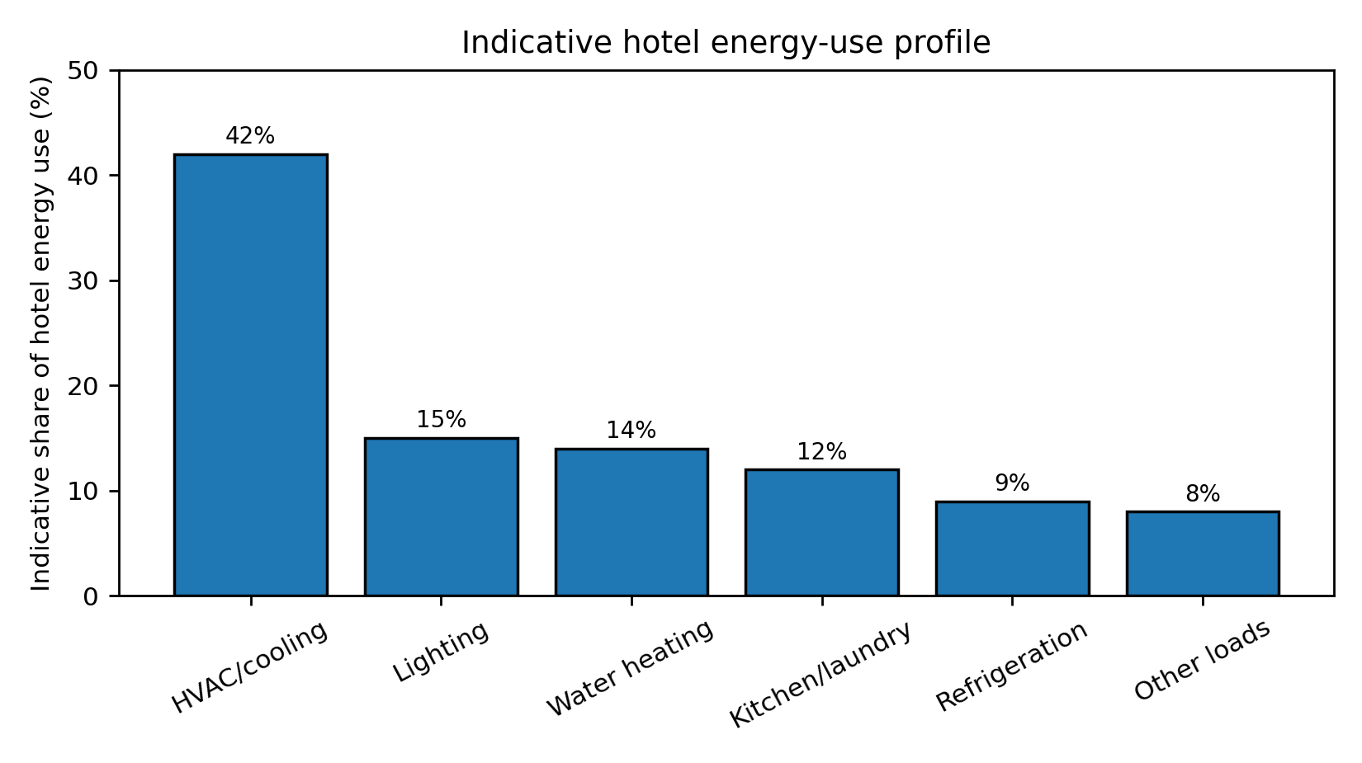
Figure 1: Indicative energy-use profile of hotel buildings. Source: Authors' synthesis from reviewed literature.
Table 1: Major hotel energy end-uses and appropriate retrofit responses.
Energy end-use | Typical drivers in hotels | Operational implication | Retrofit response
HVAC / cooling | High temperature, poor controls, old AC units, poor maintenance | High electricity and generator fuel demand | Efficient chillers/ACs, thermostats, occupancy controls, preventive maintenance
Lighting | Long operating hours, inefficient lamps, decorative lighting | Higher electricity use and heat gain | LED replacement, daylighting, motion sensors, zoning
Water heating | Laundry, kitchens, guest bathrooms | High fuel/electricity cost | Solar water heating, heat-pump water heaters, pipe insulation
Kitchen / laundry | Commercial cooking, washing, drying, ironing | Peak demand and thermal load | Efficient equipment, scheduling, maintenance, heat recovery where feasible
Refrigeration | Cold rooms, bars, kitchens and restaurants | Continuous base-load consumption | Efficient compressors, door seals, controls, maintenance
Other loads | Elevators, pumps, ICT, entertainment and security systems | Hidden energy wastage when unmanaged | Smart metering, shutdown routines, power-factor improvement

Retrofit Strategies and Expected Performance
The most effective approach for Nigerian hotels is not a single technology but a staged retrofit package. Low cost interventions should be implemented first because they create quick savings and build confidence. Medium cost system upgrades should follow after an energy audit. Capital intensive renewable energy systems should be sized after efficiency improvements so that the hotel does not overspend on oversized solar or battery systems.
Table 2: Retrofit strategies and indicative performance ranges for Nigerian hotels.
Retrofit measure | Main application | Indicative saving potential | Relative cost | Priority
LED lighting upgrade | Guest rooms, corridors, lobbies, offices, outdoor areas | 50-80% of lighting energy | Low-medium | Immediate
Occupancy sensors / key-card controls | Rooms, corridors, toilets, service spaces | 10-25% room-level savings | Low-medium | Immediate
HVAC optimisation | Chillers, split ACs, thermostats, ventilation | 15-30% cooling energy savings | Medium-high | High
Building envelope improvement | Roof, walls, glazing, doors, shading devices | 8-18% total energy savings | Medium | High in hot climates
Smart energy management / BMS | Metering, automated control, fault detection | 10-25% total savings where poorly controlled | Medium-high | Medium/large hotels
Solar PV and storage | Electricity supply and generator displacement | 20-45% grid/diesel reduction depending on sizing | High | After audit and demand reduction

Practical Retrofit Data for Interpretation
Table 3 converts the retrofit discussion into a simple planning scenario. The baseline is an illustrative medium sized hotel energy index of 100 units, showing how staged interventions can progressively reduce consumption. The values are not universal measurements but a decision-support illustration for hotel owners and facility managers.
Table 3: Illustrative staged retrofit impact for a medium-sized Nigerian hotel.
Scenario | Retrofit package | Estimated energy index | Reduction from baseline | Interpretation
Baseline | Existing inefficient systems | 100 | 0% | Current high-cost operation
Stage 1 | LED lighting, basic maintenance, shutdown rules | 88-92 | 8-12% | Quick savings, low disruption
Stage 2 | Occupancy controls and smart meters | 78-85 | 15-22% | Improved control, reduced wastage
Stage 3 | HVAC optimisation and envelope improvements | 65-75 | 25-35% | Major reduction in cooling demand
Stage 4 | Solar PV, storage and continuous monitoring | 55-70 | 30-45% | Lower grid/diesel dependence, improved resilience

Barriers to Retrofit Adoption
Despite the technical benefits, retrofit adoption in Nigerian hotels remains constrained by financial, technical and institutional barriers. Many operators focus on immediate cash flow and may delay energy upgrades because savings accrue over time. Technical capacity is also a concern because poorly designed retrofits can underperform, and weak enforcement of energy-efficiency standards reduces pressure on building owners to improve performance.
Table 4: Barriers to retrofit adoption and proposed responses.
Barrier | How it affects hotels | Recommended response
High upfront cost | Discourages investment even when lifecycle savings are attractive | Green loans, tax incentives, phased implementation, equipment leasing
Limited technical expertise | Poor audit quality, wrong equipment selection, weak maintenance | Training for facility managers, certified energy auditors, professional guidelines
Low awareness | Energy waste treated as normal operating cost | Energy benchmarking, awareness campaigns, hotel energy labels
Weak policy enforcement | Few consequences for inefficient building operation | Minimum energy performance standards and regular compliance checks
Poor access to reliable data | Owners cannot identify where energy is being wasted | Smart meters, monthly energy reporting, equipment-level monitoring
Maintenance culture | Retrofit systems fail when not properly maintained | Preventive maintenance schedules and service contracts

Implementation Pathway
A practical retrofit plan should begin with an energy audit and end with continuous monitoring. Hotels should avoid purchasing new technologies without first understanding where energy is being wasted. Figure 2 proposes a staged pathway suitable for Nigerian hotels, moving from audit through quick wins, system upgrades, renewable-energy integration and continuous monitoring.
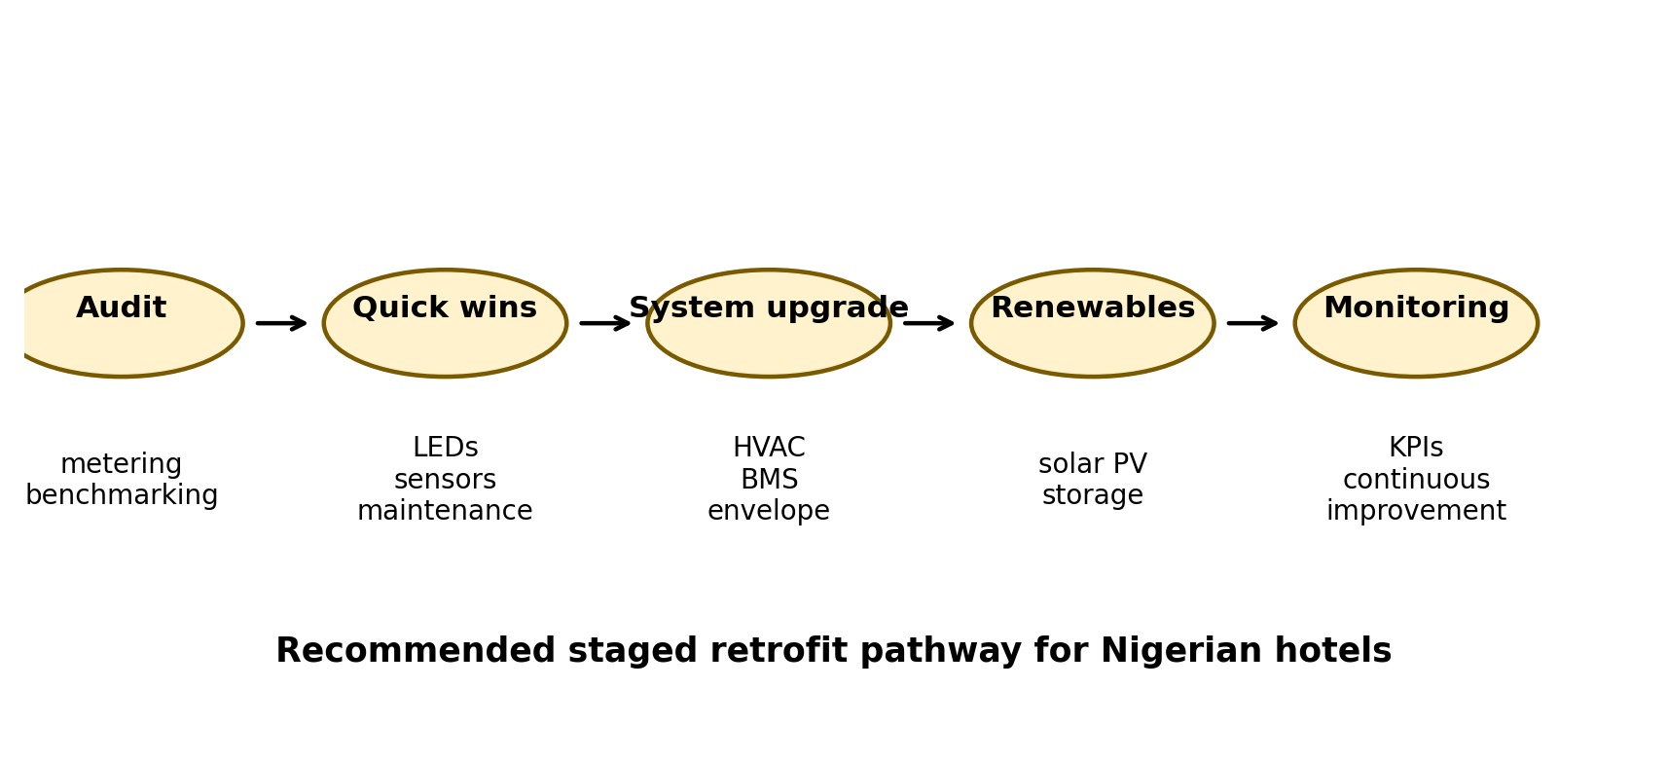
Figure 2: Recommended staged retrofit pathway for Nigerian hotels. Source: Authors' synthesis, 2026.
POLICY AND PROFESSIONAL IMPLICATIONS
The findings have implications for hotel owners, architects, engineers, quantity surveyors, facility managers and policymakers. Hotel owners should treat retrofitting as an investment in operating-cost reduction rather than an optional sustainability expense. Architects and engineers should promote passive cooling, efficient equipment selection and smart controls when upgrading existing hotels, while quantity surveyors have an important role in life-cycle cost analysis, payback assessment and value-for-money evaluation of retrofit options. Facility managers should maintain energy records, track monthly consumption and ensure installed systems continue to perform as intended.
At policy level, government and professional bodies should strengthen energy efficiency guidelines for commercial buildings, encourage green financing and support local training in building energy auditing. Energy performance contracting can also be useful because it allows retrofit investment to be repaid through verified energy savings, a model particularly relevant for hotels that need efficiency upgrades but cannot immediately fund large capital projects.
CONCLUSION
This paper examined retrofitting as a pathway for reducing energy consumption in Nigeria's hospitality industry. The review shows that Nigerian hotels face serious energy challenges arising from high cooling demand, inefficient systems, unreliable grid electricity and generator dependence. Retrofitting provides a practical route for addressing these challenges because it improves existing buildings through staged and measurable interventions. LED lighting, occupancy controls, HVAC optimisation, building envelope improvement, smart energy management and solar PV integration can collectively reduce hotel energy demand and operating costs when properly planned and maintained.
The study also established that the major gap is not the absence of retrofit technologies but the lack of structured, financeable and context specific implementation pathways for Nigerian hotels. For retrofitting to succeed, hotel owners need reliable audits, phased investment plans, trained facility managers, clear policy support and financing models that recognise long-term savings. Future studies should conduct field-based energy audits across different hotel categories in Nigeria to validate the indicative savings presented in this paper.
RECOMMENDATIONS
1. Medium and large hotels should conduct periodic energy audits to identify major sources of wastage before investing in retrofit technologies.
2. Hotel owners should adopt phased retrofit plans, beginning with LED lighting, maintenance improvement, smart metering and occupancy controls before moving to capital intensive systems.
3. Government should introduce tax incentives, import-duty relief and green-loan schemes for certified energy-efficient equipment used in commercial buildings.
4. Professional bodies should train architects, engineers, quantity surveyors and facility managers on hotel energy audits, retrofit costing and performance verification.
5. Energy performance contracting should be encouraged so that retrofit projects can be financed through future energy savings.
6. Future research should use measured electricity and fuel-consumption data from Nigerian hotels to develop local energy benchmarks.
REFERENCES
Adekunle, T. O., Nikolopoulou, M., & Amole, D. (2015). Thermal comfort adaptation in office buildings in Nigeria. Energy and Buildings, 85, 20-28.
Agharid, A. P., et al. (2024). Energy-efficient and cost-effective approaches through building retrofit scenarios for hotel buildings. Journal of Asian Architecture and Building Engineering, 24(1), 1-17.
González, A. G., García-Sanz-Calcedo, J., Salgado, D. R., & Cambero, I. (2018). Evaluation of energy consumption in hotels and proposals for improvement. Energy and Buildings, 169, 403-412.
International Energy Agency. (2024). Energy Efficiency 2024. IEA, Paris.
Ma, Z., Cooper, P., Daly, D., & Ledo, L. (2012). Existing building retrofits: Methodology and state-of-the-art. Energy and Buildings, 55, 889-902.
National Bureau of Statistics. (2024). Nigeria Electricity Report Q1 2024: Energy billed, revenue generated and customers by DISCO. NBS, Abuja.
Nigerian Electricity Regulatory Commission. (2024). Fourth Quarter 2023 Quarterly Report. NERC, Abuja.
Ogunjuyigbe, A. S., Ayodele, T. R., & Ogunmuyiwa, S. M. (2020). Retrofitting existing buildings to reduce electrical energy consumption and greenhouse gas emission in Nigerian food and beverage industries. Journal of Electrical Systems and Information Technology, 7(9), 1-15.
Oluseyi, P. O., Babatunde, O. M., & Babatunde, O. A. (2016). Assessment of energy consumption and carbon footprint from the hotel sector within Lagos, Nigeria. Energy and Buildings, 118, 106-113.
Pérez-Lombard, L., Ortiz, J., & Pout, C. (2008). A review on buildings energy consumption information. Energy and Buildings, 40(3), 394-398.
United Nations Environment Programme & Global Alliance for Buildings and Construction. (2024). Global Status Report for Buildings and Construction 2024/2025. UNEP, Nairobi.
World Bank. (2020). Nigeria Power Sector Recovery Program. World Bank, Washington, DC.
Zhiri, G. H., & Bawa, J. A. (2024). Investigation of the energy use pattern in hotel buildings in tropical savannah climate: A case study of Minna. International Journal of Advanced Natural Sciences and Engineering Researches, 8(10), 121-128.

